
July 1st – July 31st
Ag. District 5
8-Year Review

30-Day Review Period

All Municipalities in Cattaraugus County

Cattaraugus County Agricultural & Farmland Protection Board will be accepting requests for modifications from any municipality, landowner, or State Agency whose territory is within Agricultural District No. 5. Agricultural District No. 5 encompasses 239,537 acres, and is located within every municipality in Cattaraugus County. Landowners may submit requests to add parcel(s) of predominantly viable agricultural land or remove parcel(s). Requests must be received no later than August 1st.

To submit a request to add or remove parcel(s) from the Agricultural District, landowners may fill out an online form available at this link: www.CattCo.Gov/Ag-Review

Landowner requests can either be mailed to Cattaraugus County Economic Development, Planning & Tourism (303 Court Street, Little Valley, NY 14755), or emailed to csmaxwell@cattco.org.
A map of the district is on file and open to public inspection at the Clerk’s Office of the Cattaraugus County Legislature in Little Valley, New York.

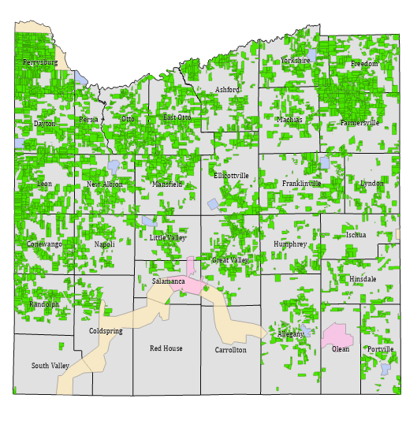
For more information visit www.CattCo.org/planning/ag-districts

Cattaraugus County
Department of Economic Development, Planning & Tourism
716-938-2387
www.CattCo.org

