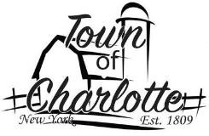
TOWN OF CHARLOTTE COUNTY OF CHAUTAUQUA STATE OF NEW YORK
The Town Board, Town of Charlotte held a regular Board Meeting on Wednesday, March 11, 2026 at 7:00 p.m. in the Sinclairville Volunteer Fire Department, Francis Lauricella Jr., Town Supervisor presiding. Board members present were: Mark Jaquith, Scott Dibble, Harold North and Larry Green. Other’s present were: Mark LeBaron; Highway Superintendent, Jeffrey Crossley; Town Justice, Wanda Crossley; Court Clerk, Joe McKenna; Sinclairville Volunteer Fire Department Chief, Allen & Hope Fredrickson, and Susan L. Peacock; Town Clerk.

The meeting was called to order.

Prayer was offered by Scott Dibble followed by the Pledge of Allegiance.

Each board member had been given a copy of the minutes of the February 11, 2026, board meeting. A motion was made by Harold North seconded by Mark Jaquith and with none opposed it carried to accept the minutes as presented.

A motion was made by Mark Jaquith, seconded by Scott Dibble and with none opposed it carried to draw warrants on the proper funds in payment of Highway Claims No. 26 to No. 40 in the amount of $13,566.41 which have been duly audited and to draw warrants on the proper funds in payment of General Fund Claims No. 42 to No. 74 in the amount of $69,040.56 which have been duly audited.
A motion was made by Harold North, seconded by Mark Jaquith and with none opposed it carried to accept the February 2026 Financial Report prepared for the Town of Charlotte by Bahgat Laurito & Bahgat.
A motion was made by Harold North, seconded by Mark Jaquith and with none opposed it carried to move forward to utilize the CHIPS funding toward a new truck for the Highway Department applying 2026 and 2027 funding towards the truck and taking delivery of the truck in 2027.
A motion was made by Mark Jaquith, seconded by Larry Green and with none opposed it carried to allow the Town to enter into a contract with the Chautauqua County Humane Society for 2026.
A motion was made by Larry Green, seconded by Harold North and with none opposed it carried to set the Town’s clean up day for Saturday, May 9, 2026 from 8am – 4pm at the Town Highway Department.

Discussion was heard on the following:

HIGHWAY REPORT:
- Plowing and sanding roads
- Posted Roads
- Repairs on plow trucks, servicing equipment
- Hauling 1a stone for chip sealing and ice control sand
- Fixing shoulder washouts

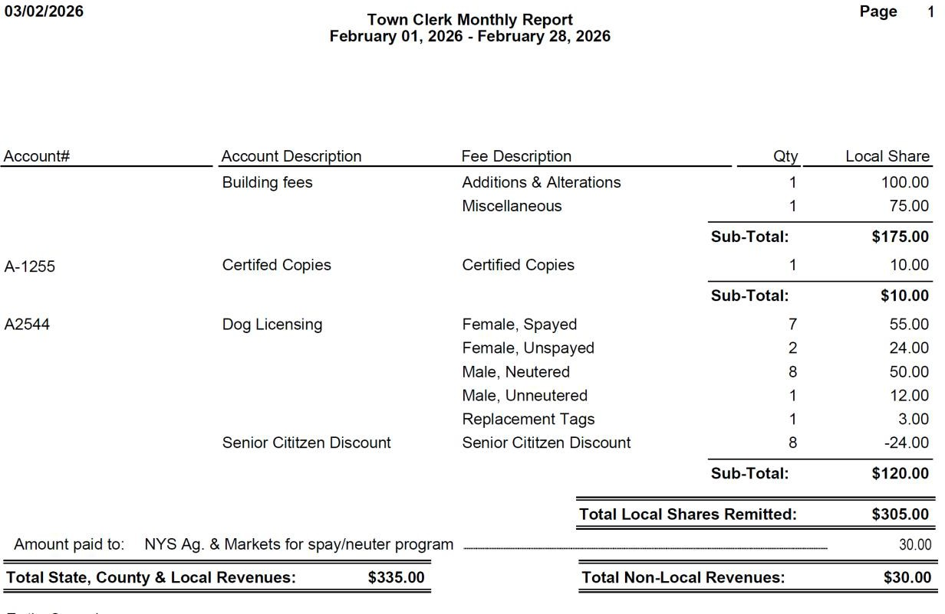
- CLERK REPORT: February scheduled hours were 34.5 with 65 hours actually worked leaving the total amount of 30.5 hours over the scheduled hours. The Justice audit has been filed with the Justice Committee via email. A rouge EZpass charge is being disputed. The following report was presented:

The following report was received from the Sinclairville Fire Department:

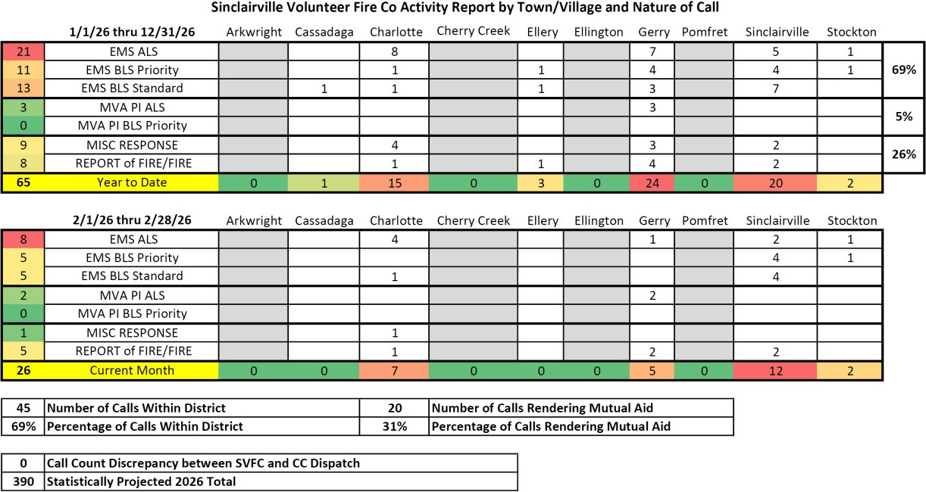

- TAX COLLECTOR REPORT: For February 2026, taxes were collected on 751 parcels totaling $907,664.80. This amount is considerably more than last February due to a later first due date.

- JUSTICE REPORT: Justice Jeffrey Crossley reported low tickets in February due to the weather. The grant was approved for $15,350.00, about half the amount of what was requested. Consolidation talks with Ellington Justice Court have begun. The following report was presented:

DISPENSING JUSTICE FOR ALL
2026

 | NEW CHARGES |  | CALENDARED CASES | CLOSED CHARGES
JAN |  | 19 | 174 | 46
FEB MAR APR MAY JUNE  JUL |  | 30 | 77 | 45
AUG SEPT OCT NOV
DEC

TOTAL OPENED CHARGES TOTAL CALENDRED TOTAL CLOSED CHARGES
49 251 91

TOTAL CHARGES DEALT WITH TO DATE 2025
391

PETTY CASH FUND IS TRAINING COMPLETED
$ 150.00

JUDGE MANDATORY12HOURS

EXTRA CREDIT JUDGE TOTAL
COURT CLERK MANDATORY 6 HOURS EXTRA CREDIT
CLERK TOTAL

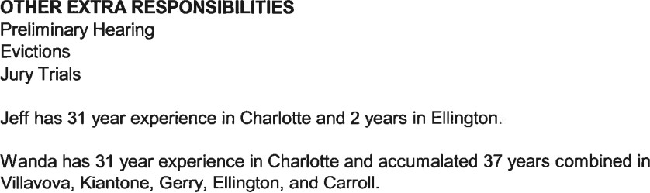

- ASSESSORS REPORT: From Kevin Okerlund via email:
March 2026

Legal notices were filed for two consecutive weeks in the Post Journal as required by the State regarding assessment inventory.

I will be starting field work within the next couple of weeks to finish up by May 1, 2026. Thank you.
- DCO REPORT: Via text from Joshua Cybard:

I am currently working on this month’s delinquent dogs, and last month had two dogs
get out but their owner found them.
- Joe McKenna reported the next chicken barbeque at the Fire Hall will be Sunday, March 22, 2026 with no raise in prices for the chicken dinners. An audit was conducted on the Fire Department’s financials for 2025. The audit
found no problems and also used the word “excellent” when it came to the
record keeping.
- Jeffrey Crossley reported that the Chautauqua County History Expo will be Sunday, August 2, 2026 from 10am – 4pm at the Chautauqua Municipal
Building, 2 Academy St., Mayville. This is a free event celebrating America’s 250th
and is open to the public.

A motion to adjourn was made by Mark Jaquith, seconded by Harold North and with none opposed it carried.

The next regular Town Board Meeting is scheduled for Wednesday, April 8, 2026, at the Sinclairville Volunteer Fire Department, 30 Main St. Lower, Sinclairville, NY. Anyone interested is welcome to attend.

Respectfully submitted. Susan Peacock
Town Clerk/Tax Collector/Registrar

