
TOWN OF CHARLOTTE
COUNTY OF CHAUTAUQUA
STATE OF NEW YORK

The Town Board, Town of Charlotte held its Organizational Meeting on Wednesday, January 14, 2026 at 6:00 p.m. in the Sinclairville Volunteer Fire Department Hall, Francis Lauricella, Supervisor presiding. Board members present were: Scott Dibble, Harold North, Larry Green and Mark Jaquith. Others present were: Mark LeBaron; Highway Superintendent, Jeff Crossley; Town Justice, Wanda Crossley; Town Court Clerk, Joe McKenna; Sinclairville Volunteer Fire Department Chief, Al & Hope Fredrickson, Susan L. Peacock; Town Clerk. The meeting was called to order, prayer was offered by Frank Lauricella followed by the Pledge of Allegiance.

** A COPY OF THE TOWN’S CURRENT ZONING FEE SCHEDULE, AND DCO PROTOCOL IS GIVEN TO ALL BOARD MEMBERS AND TOWN SUPERVISOR. **

** A COPY OF THE TOWN’S PROCURMENT POLICY & CODE OF ETHICS IS GIVEN TO ALL BOARD MEMBERS AND CURRENT OFFICERS **

The following resolution was offered by Mark Jaquith, seconded by Harold North and with none opposed it carried.
RESOLVE that the Town Board, Town of Charlotte does hereby fix the salaries of the following town officials and appointments for the year beginning January 1, 2026 in the amounts respectively stated in the current 2026 budget and that such salaries be payable as follows:
FIX TOWN OFFICIALS SALARIES PAY CYCLE
SUPERVISOR $ 8,320.00 MONTHLY
TOWN JUSTICE 12,533.00 BI-WEEKLY
COUNCILMEN (4 @ $1622 ea) 6,488.00 YEARLY
DEPUTY SUPERVISOR 1,560.00 YEARLY
HIGHWAY SUPT. 62,733.00 BI-WEEKLY
TOWN CLERK 22,000.00 BI-WEEKLY
ASSESSOR 10,305.00 MONTHLY
BLDG. CODE OFFICER 5,013.00 MONTHLY
ZONING OFFICER 5,013.00 MONTHLY
DOG CONTROL OFFICER 5,013.00 MONTHLY
COURT CLERK 14,917.00 MONTHLY
TOWN HISTORIAN 650.00 YEARLY

A motion was made by Mark Jaquith, seconded by Harold North and with none opposed it carried to:

appoint Building Code Enforcement Officer Toby Hammond 1/1 – 12/31/2026.

appoint Zoning Officer Toby Hammond 1/1– 12/31/2026 as well as provide stipend of $100 to all 4 Board members, Chairman and Secretary per meeting.

The Town Board reviewed the Zoning Fee Schedule for Building Permits.

appoint Joshua Cybart as the Dog Control Officer 1/1 – 12/31/2026 and the DCO Protocol was reviewed.

appoint Town Historian Susan Peacock 1/1 – 12/31/2026.

appoint Registrar Susan L. Peacock 1/1 – 12/31/2026.

Registrar Susan L. Peacock appointed Matthew Riggle as Deputy Registrar 1/1 – 12/31/2026.

set the salary for the Deputy Clerk at $17.00 per hour.

assign the following:

COMMITTEE APPOINTMENTS:

ASSESSMENT & JUDICIAL (MARK JAQUITH, SCOTT DIBBLE)
HIGHWAY & PUBLIC SAFETY (LARRY GREEN, HAROLD NORTH)
RECREATION (LARRY GREEN)
AUDIT COMMITTEE (HAROLD NORTH, MARK JAQUITH)
CEMETERY COMMITTEE (SCOTT DIBBLE)

Town Justice Jeffrey Crossley appointed Wanda Crossley as the Court Clerk 1/1 – 12/31/2026.

Town Justice Jeffrey Crossley appointed Thomas Atwell as the Court Watch keeper 1/1 -12/31/2026 at the salary of $17.00 per hour.

appoint the Chief Fiscal and Budget Officer Town Supervisor Francis Lauricella 1/1 – 12/31/2026.

Town Supervisor Lauricella appointed Harold North as Deputy Town Supervisor.

that pursuant to Section 284 of the Highway Law an agreement be entered into between Mark LeBaron, Highway Superintendent of the Town of Charlotte and the Town Board for the expenditure of Highway money for General Repairs and Improvements in the amount of $369,338 on 44.92 miles of Town Highways.

authorize utility & other bills received after Town Board meetings and the purchase of postage may be paid before being approved by the next month’s abstract.

set the stipend for cell phone at 300.00 yearly for each:
TOWN CLERK
HIGHWAY SUPERINTENDENT
ZONING/BUILDING OFFICER
DOG CONTROL OFFICER
TOWN SUPERVISOR

Town Board members reviewed the Town’s Procurement Policy as required by guideline 5 of the policy. Accept the Procurement Policy as presented.

authorize Town Officers to attend any training needed for their positions when required or available.

authorize Town Officers to attend the annual Association of Towns meeting in New York City.

Town Highway Superintendent Mark LeBaron appointed Tim Cobb as the Deputy Highway Superintendent 1/1 – 12/31/2026.

authorize payment of health insurance for Mark LeBaron, Zachary Wise and Glen Fisher.

renew the Shared Service Agreement with Chautauqua County.

that the Highway Superintendent is hereby authorized to advertise for bids for Highway building materials for the 2026 season and/or accept the County Bid.

set a stipend in the amount of $100 each ($400 total) for high visibility clothing for the Highway workers.

authorize Community Bank N.A., NY Class and M&T Bank as official depositories of the Town.

allow the Town Clerk, Town Supervisor, and Bookkeeper Dan Laurito to continue using the online banking option with Community Bank N.A. and direct pay with National Grid.

continue having a Town Mastercard credit card through Community Bank N.A. Any and all purchases would be made by designated Town Officials; Town Clerk, Highway Superintendent and Town Supervisor. All purchases will be in accordance with the Town procurement policy. The Town Supervisor, Town Clerk and Town Highway Superintendent will have cards.

that the Jamestown Post Journal be designated as the Official newspaper for the publication of official notices, proceedings and reports provided by law to be published.

to set the Town Board meetings as follows: 7:00 P.M. 2ND WED. OF MONTH - EXCEPT OCTOBER (BEFORE 5TH) & NOVEMBER (BY THURSDAY AFTER ELECTION DAY 11/3) (2/11, 3/11, 4/8, 5/13, 6/10, 7/8, 8/12, 9/9, 10/1, 11/4, 12/9/2026) AT THE SINCLAIRVILLE VOLUNTEER FIRE DEPARTMENT.

setting the mileage rate for the use of private vehicles by Town Officials when traveling on official business at the 2026 Federal minimum rate of $.72.5 per mile.

approve the Town of Charlotte continue the website http://www.charlotteny.gov & website maintenance with Weebly & Southern Tier West at the cost of $600 for the year.

authorizing Francis Lauricella, Supervisor to enter into agreements for 1/1 – 12/31/2026 with the following:
Attorney Lundberg Price PC @ $200 per hour
Valley Historical Society for $2,500.00 under A7540.4
The Program for the Aging (76ers) $6,000.00 under B6772.4
Chautauqua County Sheriff's Paid Patrol & Court Services $10,000
Appropriate $1,500.00 to the Village of Sinclairville for youth recreation under B7310.4 Appropriate $400.00 to the Village of Sinclairville for band concerts under A7270.4
Langford Testing for Highway employees

A motion was made by Larry Green seconded by Mark Jaquith, and with none opposed it carried to approve the minutes from the 12/29/25 meeting.
A motion was made by Scott Dibble, seconded by Larry Green and with none opposed it carried to draw warrants on the proper funds in payment of Highway Claims No. 1 to No. 7 in the amount of $118,092.20 which have been duly audited and to draw warrants on the proper funds in payment of General Fund Claims No. 1 to No. 20 in the amount of $15,107.17 which have been duly audited.
A motion was made by Harold North, seconded by Mark Jaquith and with none opposed it carried to accept the December 2025 Financial Report prepared for the Town of Charlotte by Bahgat & Laurito - Bahgat.
Discussion was heard on the following:

1. HIGHWAY REPORT:

Servicing plow trucks & equipment

Plowing and sanding Roads
3. Hauling ice control sand

2. CLERK REPORT: December scheduled hours were 35.5 with 45 hours actually worked leaving the total amount of 9.5 hours over the scheduled hours. The following report was presented:

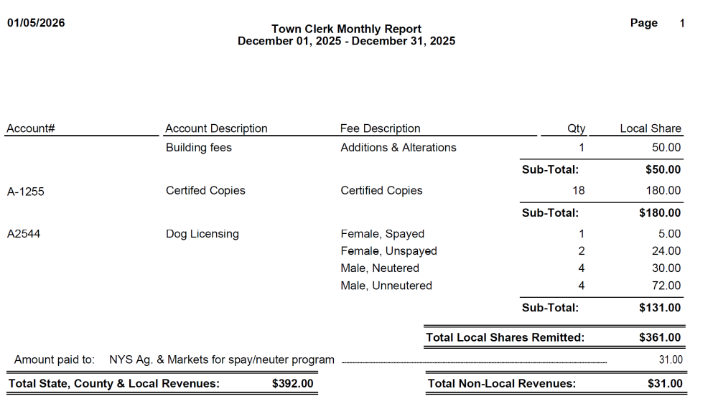

An following annual 2025 yearly Town Clerk Report was also presented, with reporting total hours scheduled for 2025 was 416.5 and total hours worked was 537 showing an overage of 120.5 hours worked to scheduled.
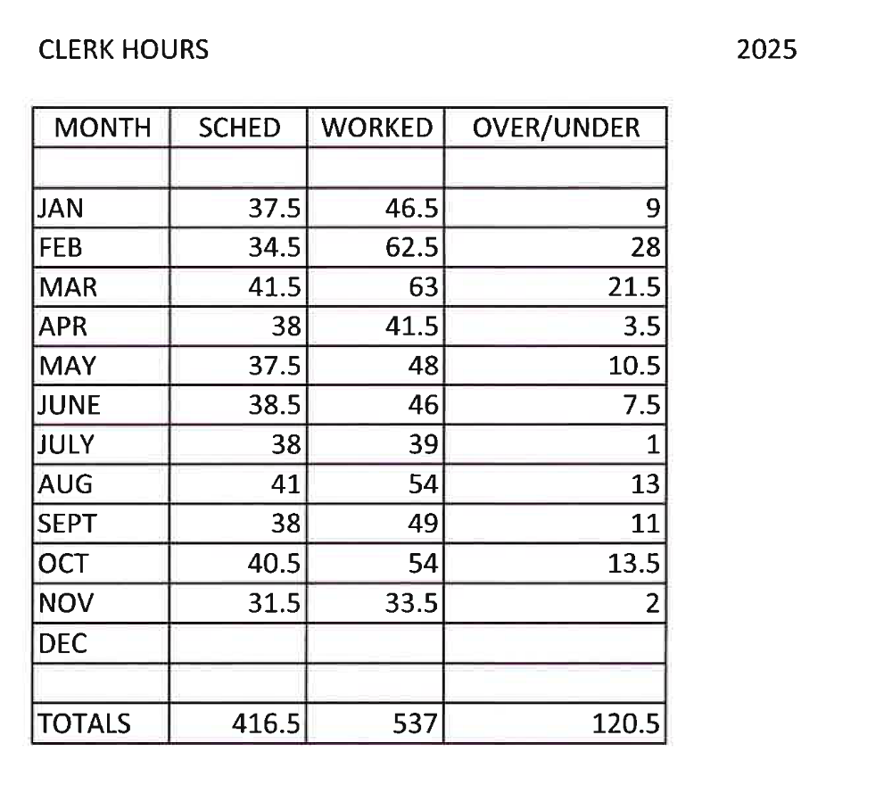

The following report for the year 2025 was received from the Sinclairville Fire Department:
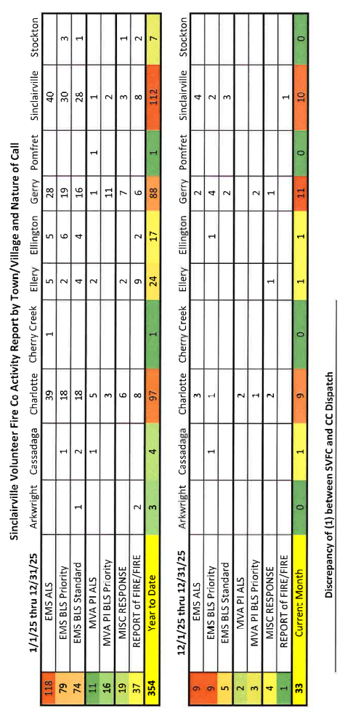

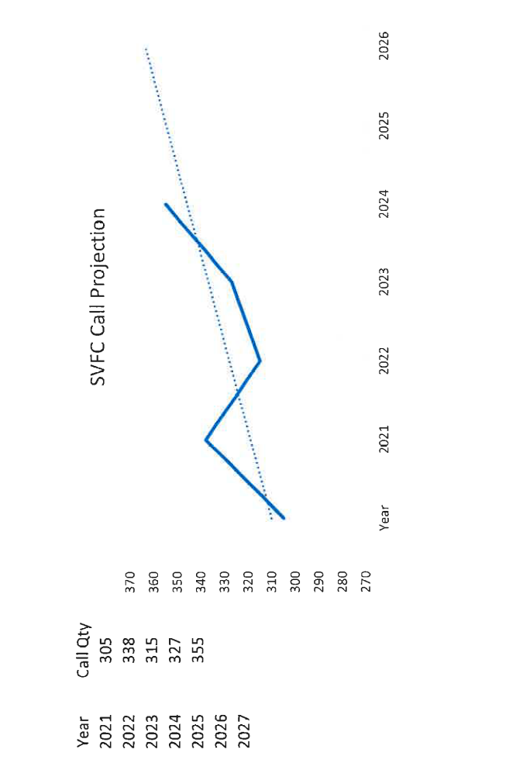
3. TAX COLLECTOR REPORT: The County prepared our tax bills and they have been mailed 1/6. Tax collection began 1/9/25. The Tax Collection Warrant has been received from the County and is displayed in the Clerk’s office. Escrow payments were mistakenly mailed to homeowners in error. They were sent to their respective banks as well. Payments are trickling in.
4. JUSTICE REPORT: Justice Jeffrey Crossley reported that there was no end of year report yet. He will be bringing 36 chairs over for the new meeting room upstairs of the Court. Also a new table is needed. Jeff will coordinate with Mark LeBaron and the Highway department to help with the move.

5. Historian Report: Susan Peacock, Historian, reported the year 2025 in the History Report binder.
The next regular Town Board Meeting is scheduled for Wednesday, February 11, 2026 at 7:00pm at the Sinclairville Volunteer Fire Department, 30 Main St., Sinclairville, NY. Anyone interested is welcome to attend.

Respectfully submitted.
Susan L. Peacock

