
TOWN OF CHARLOTTE COUNTY OF CHAUTAUQUA STATE OF NEW YORK
The Town Board, Town of Charlotte held a regular Board Meeting on Wednesday, February 11, 2026 at 7:00 p.m. in the Sinclairville Volunteer Fire Department, Francis Lauricella Jr., Town Supervisor presiding. Board members present were: Mark Jaquith, Scott Dibble, Harold North and Larry Green. Other’s present were: Mark LeBaron; Highway Superintendent, Jeffrey Crossley; Town Justice, Joe McKenna; Sinclairville Volunteer Fire Department Chief, Cody Johnson, Allen & Hope Fredrickson, and Susan L. Peacock; Town Clerk.

The meeting was called to order.

Prayer was offered by Scott Dibble followed by the Pledge of Allegiance.

Each board member had been given a copy of the minutes of the January 14, 2026, board meeting. A motion was made by Mark Jaquith seconded by Larry Green and with none opposed it carried to accept the minutes as presented.

A motion was made by Harold North, seconded by Mark Jaquith and with none opposed it carried to draw warrants on the proper funds in payment of Highway Claims No. 8 to No. 25 in the amount of $25,548.60 which have been duly audited and to draw warrants on the proper funds in payment of General Fund Claims No. 21 to No. 41 in the amount of $9,339.90 which have been duly audited.
A motion was made by Mark Jaquith, seconded by Larry Green and with none opposed it carried to accept the January 2026 Financial Report prepared for the Town of Charlotte by Bahgat Laurito & Bahgat.
A motion was made by Harold North, seconded by Larry Green and with none opposed it carried to approve the Town’s Justice Audit performed by the Audit Committee consisting of Harold North & Scott Dibble.
A motion was made by Harold North, seconded by Larry Green and with none opposed it carried to accept the bid from Schneider Services, Inc. to provide new lighting in the highway building at the estimated cost of $6700.00.
A motion was made by Larry Green, seconded by Mark Jaquith and with none opposed it carried to remove David Christy from the Board of Assessment Review.
A motion was made by Larry Green, seconded by Scott Dibble and with none opposed it carried to appoint Cody Johnson to the Board of Assessment Review for a 4 year term

ending 12/31/2029 and the Zoning Board of Review for a 6 year term ending 12/31/2031.
A motion was made by Mark Jaquith, seconded by Harold North and with none opposed it carried to appoint Tom Atwell as Watchkeeper as of 2/23/26.
A motion was made by Mark Jaquith, seconded by Larry Green and with none opposed it carried to allow Toby Hammond; Building Code Officer, to explore the options of
“opting out” of the new Energy Code put forth by NYS.

Discussion was heard on the following:

HIGHWAY REPORT:
- Plowing and sanding roads
- General repairs on plow trucks
- Hauling ice control sand
- Sold 3 pieces of surplus equipment

- CLERK REPORT: January scheduled hours were 34.5 with 46.5 hours actually worked leaving the total amount of 12 hours over the scheduled hours. A copy of this year’s meeting dates was given to all Town Board members. All Town/NYS mandated training has been completed by the Town Clerk. The following report was presented:

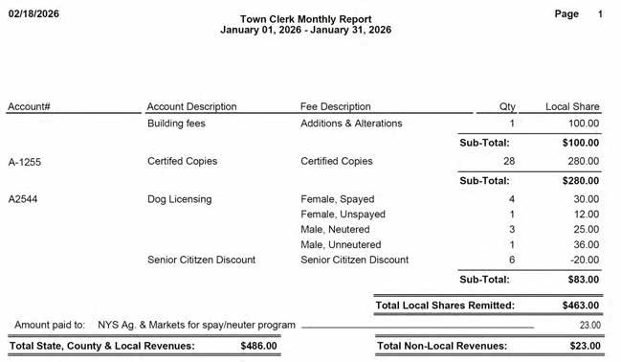

The following report was received from the Sinclairville Fire Department:

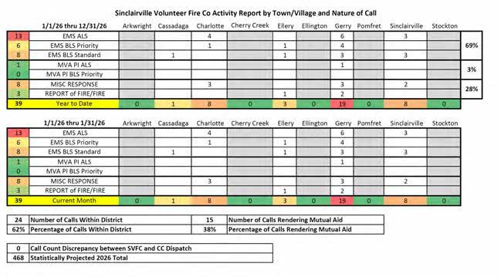

- TAX COLLECTOR REPORT: For January, 2026, taxes were collected on 191 parcels totaling $214,936.76. This amount is considerably less than last January due to a later due date. Tax warrant checks were given to the Town Supervisor fulfilling the 2026 warrant.
- JUSTICE REPORT: Justice Jeffrey Crossley reported that there is no printed report this month. All Town/NYS mandated training has been completed. New Court training is forthcoming. New penalties are being implemented by NYS in February.

- ASSESSORS REPORT: From Kevin Okerlund via email:
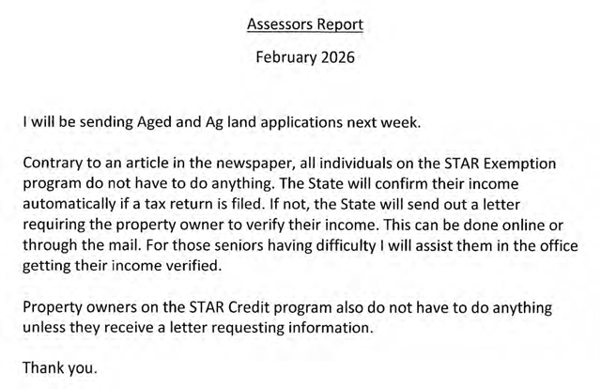

- Joe McKenna reported the next chicken barbeque at the Fire Hall will be Sunday, March 22, 2026. The Town Board thanked the Sinclairville Volunteer Fire Department Volunteers for their service to our Town and community.

A motion to adjourn was made by Harold North, seconded by Mark Jaquith and with none opposed it carried.

The next regular Town Board Meeting is scheduled for Wednesday, March 11, 2026, at the Sinclairville Volunteer Fire Department, 30 Main St. Lower, Sinclairville, NY. Anyone interested is welcome to attend.

Respectfully submitted. Susan Peacock
Town Clerk/Tax Collector/Registrar

