Town of New Albion
7151 Route 353
Cattaraugus, NY 14719
Regular Board Meeting
March 16, 2026, 7:00 p.m.

PRESIDING: Patrick Murphy, Supervisor

PRESENT: Councilmen: Cynthia Eaton; Michael Weishan; Frank Watson, Code Enforcer; Sherry Rupp, Town Clerk.

ABSENT: Daniel Goss; Norman Kazmark; George Borrowdale, Highway Superintendent.

VISITORS: Michael Smith.

CALL TO ORDER: Supervisor Murphy called the meeting to order at 7:00 pm. Followed by the Pledge to the American Flag. Regular Minutes for February 16, 2026.Town Clerk Monthly Report, and the Register’s Report were all approved as presented by the Clerk.

CORRESPONDENCE:

- NYS DOT (SEQR) Report Request
- Invite to Cattaraugus Firemen’s Installation Banquet
- Southern Tier West Annual Conference
- NYS Association of Towns Financial and Personnel Conference

REPORTS:

Michael Smith: mentioned that in the new building instead of having two doors to just have one door that measures 16x14. Do we have a timeline? Michael Weishan responded 12-16 weeks for a Design. I’m in the middle of getting quotes for a plow truck. We are working on the 550’s hydraulics. Patrick asked about a seasonal worker to mow. Mike said that someone put their application in and gave it to George.

Code Enforcer: Frank Watson, Notices were sent out to the Greene’s, property needs to be cleaned up. Received a check for an electrical permit, the town does not issue electrical permits. Return the check. I received an application for two buildings that were built without a permit.

Highway Dept.: George Borrowdale, none.

Treasurer: Eugene Doucette, Expenditure, Assets & Liabilities, and Revenue Reports.

Assessor: Elizabeth Lerow, the February report is as follows:

- Because exemption renewal applications are due March 1, February is always one of our busiest months answering taxpayer questions, processing applications, contracting applicants for additional information, etc. In order to best serve these applicants, we also take time to call those who have not returned sufficient backup with their renewal applications. Reminder letters were sent in early February to all applicants whose application had not yet been received.
- Renewal applications for Agricultural Assessment and Senior Citizen Exemption are being submitted and processed. So far, 93% of Agricultural Assessment and 92% of Senior Citizen renewal applications have been processed.
- 58 properties were reviewed for Roll Year 2026; this includes building permits as well as internal reviews flagged by our office for various reasons.
- The Assessing Office has corresponded with several property owners about their assessments, tax bills, and exemptions.
- There were four property transfers in January. You can find more information about these sales here:
https://www.cattco.org/real-property-and-gis/sales

Board:
Councilman Patrick Murphy – None
Councilman Norman Kazmark – None
Councilman Daniel Goss – None
Councilman Cynthia Eaton – None
Councilman Michael Weishan – I would like to attend the Towns Financial and Personnel Conference in April. The cost is $250.00.

Resolution # 30- 2026 – NYS AOT Conference
On a motion by Councilman Eaton, seconded by Councilman Murphy, the following resolution was

ADOPTED Aye 3 Weishan, Eaton, and Murphy
Nay 0
Resolved, approved for Michael Weishan to attend the NYS AOT Conference in April.

CLERKS REPORT:
Clerk Report: February 2026, Amount Collected $ 235.00
Animal Population Control: Check # 2840 - $ 10.00.
Town of New Albion: Check # 2841 - $284.00
General B-Impoundment Fees: Check# 2839 - $100.00
Amount Paid Out $ 235.00

- April 11, 2026, is the Cattaraugus Firemen’s Installation Banquet. RSVPs are due by March 27th.
- Southern Tier West Annual Conference is on June 4, 2026.
- The Employer Premium Contribution 2025 Report for Health Insurance has been submitted.
- Frank Watson has completed his 2025 Code Administration Reporting.
- I checked the Hazard Mitigation website today and there is still currently no funding opportunities available at this time.
- Also, David Rupp spent a week here going through boxes gathering documents that the lawyer requested, regarding the Waverly St. Bridge. These documents were then mailed off to Rizzo’s office.

Resolution # 31- 2026 – Transfer Funds
On a motion by Councilman Weishan, seconded by Councilman Eaton, the following resolution was

ADOPTED Aye 3 Weishan, Eaton, and Murphy
Nay 0
RESOLVED, approved transfer $250,000.00 from General A Checking to Savings.

Resolution # 32- 2026 – Transfer Funds
On a motion by Councilman Weishan, seconded by Councilman Eaton, the following resolution was

ADOPTED Aye 3 Weishan, Eaton, and Murphy
Nay 0
RESOLVED, approved transfer $80,000.00 from Highway Townwide Savings to Checking.

Resolution # 33- 2026 – Create Expense Line Item
On a motion by Councilman Weishan, seconded by Councilman Eaton, the following resolution was

ADOPTED Aye 3 Weishan, Eaton, and Murphy
Nay 0
RESOLVED, approved to create an expense line item in Highway Townwide for attorney’s 1420.4.

Resolution # 34- 2026 – Transfer Funds
On a motion by Councilman Eaton, seconded by Councilman Weishan, the following resolution was

ADOPTED Aye 3 Weishan, Eaton, and Murphy
Nay 0

RESOLVED, approved to transfer $14,645.00 from Highway Reserve Waverly/Lovers Lane Savings account to Highway Townwide 1420.4.

Resolution # 35- 2026 – Transfer funds
On a motion by Councilman Weishan, seconded by Councilman Eaton, the following resolution was

ADOPTED Aye 3 Weishan, Eaton, and Murphy
Nay 0

RESOLVED, approved to transfer $686.34 from Contingent account in General A 1990.4 to Unemployment Insurance #9050.8 in General A.

Resolution # 36- 2026 – Proposal / Agreement Form
On a motion by Councilman Weishan, seconded by Councilman Eaton, the following resolution was

ADOPTED Aye 3 Weishan, Eaton, and Murphy
Nay 0

RESOLVED, approved, Patrick Murphy to sign the Proposal and Agreement Form with E & M Engineers.

Resolution # 37- 2026 – URGING IMMEDIATE REVIEW OF ELECTRIC DELIVERY CHARGES DEMANDING IMPROVED COST CONTROLS AND TRANSPARENCY, AND AUTHORIZING FORMAL COMPLAINTS TO THE NEW YORK STATE PUBLIC SERVICE COMMISSIONREGARDING THE ESCLATING COST OF ELECTRICITY
On a motion by Councilman Eaton, seconded by Councilman Weishan, the following resolution was

ADOPTED Aye 3 Weishan, Eaton, and Murphy
Nay 0
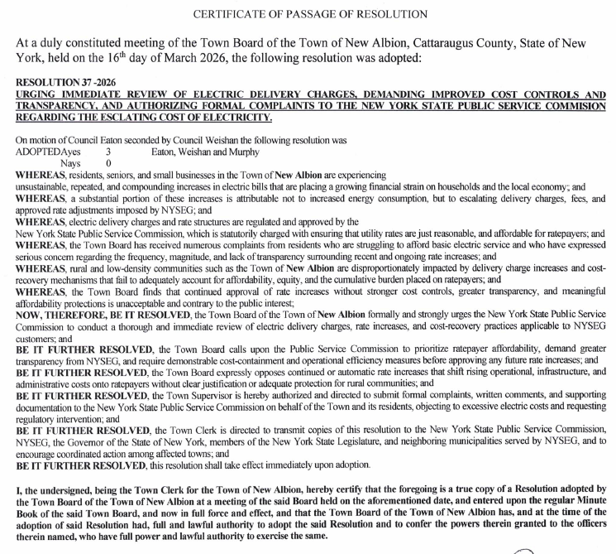

OLD BUSINESS:

- Hazard Mitigation Project

NEW BUSINESS:

- Abstract #3 – March 16, 2026
- Pay the Bills

APPROVAL OF ABSTRACT:

Resolution # 38- 2026– Abstract # 3 – 2026 – March 16, 2026
On a motion by Councilman Weishan, seconded by Councilman Eaton, the following resolution was

ADOPTED Aye 3 Weishan, Eaton, and Murphy
Nay 0

RESOLVED, that Abstract # 3 -2026 in the following amounts is to be paid.

ACCOUNT VOUCHER # TOTAL EXPENDITURES
General A 13438-13460 $ 266,957.16
General B 1094-1097 $ 986.33
Highway DA 9897-9908 $ 89,713.01
Highway DB 4073-4081 $ 32,778.89

With no further business to discuss, the meeting was adjourned at 7:47pm
pm.

Respectfully submitted,

Sherry Rupp, RMC
Recording Secretary
Town of New Albion Town Council

Next Meeting: Regular Board Meeting April 20, 2026

