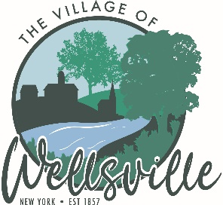

Village of Wellsville

Office of the Clerk
23 North Main Street * Wellsville, New York 14895
Phone: (585) 596-1754 * FAX: (585) 593-7260
711(TDD)

VILLAGE BOARD MEETING AGENDA
6-8-2026

Pledge to the Flag

Accept the minutes for the Regular Meeting held on Tuesday, May 26, 2026.

VISITORS: PLEASE TAKE NOTE Visitors on the agenda are limited to 10 minutes time
Visitors not on the agenda are limited to 3 minutes time

Angela Glickstein – Flowers & Memorial Park

MAYOR’S BUSINESS:

- Discuss a report from MACE on the unsafe structure at 96 Railroad Ave.
- Set a Public Hearing Date
- Early Voting June 13, 2026 – June 21, 2026 in the Village Board Room daytime hours only.

TRUSTEES’ BUSINESS:

PEARSON:

- Request acceptance and approval of the vouchers as listed in the Abstract of Vouchers dated June 8, 2026.
COLLIGAN:

- Code Enforcement Activities Report.
- Discuss the Theater User Agreement
- Request Executive Session for potential legal matter.
ROESKE:

- Nothing to discuss.
DIDION:

- Nothing to discuss.

POLICE DEPT:

- Nothing to discuss.

FIRE DEPT:

- Nothing to discuss
DPW:

- Nothing to discuss
ATTORNEY:

- Nothing to discuss
CODE ENFORCEMENT:

1. Nothing to discuss

TREASURER:

- Nothing to discuss.

