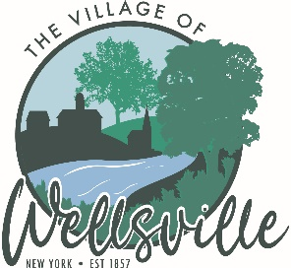

Village of Wellsville

Office of the Clerk
23 North Main Street * Wellsville, New York 14895
Phone: (585) 596-1754 * FAX: (585) 593-7260
711(TDD)

VILLAGE BOARD MEETING AGENDA
10-12-2026

Pledge to the Flag

Accept the minutes for the Regular Meeting held on Monday, October 12, 2026.

VISITORS: PLEASE TAKE NOTE Visitors on the agenda are limited to 10 minutes time
Visitors not on the agenda are limited to 3 minutes time

MAYOR’S BUSINESS:

- Nothing to discuss

TRUSTEES’ BUSINESS:

PEARSON:

- Request acceptance and approval of the vouchers listed in the Abstract of Vouchers dated October 12, 2026.
- Request acceptance and approval of August 2026 Posting Journal, Financial Statements, Bank Rec and Treasurer’s Report.

COLLIGAN:

- MACE activities.
ROESKE:

- Nothing to discuss.

DIDION:

- Nothing to discuss

POLICE DEPT:

- Acceptance and approval of the resignation of Seth Farrand.
FIRE DEPT:

- Nothing to discuss.
TOWN LIAISON:

- Nothing to discuss.
DPW:
- Nothing to discuss

CODE ENFORCEMENT:

- Nothing to discuss.
TREASURER:

- Approval of a NY Forward Small Project Fund Revolving Loan Application for $55,000 for C&D Professional to cover bridge financing for grant funding.
- Acceptance and approval of the Resolution 2627-10 for the purchase of a landfill pump.
- Acceptance and approval of the Resolution 2627-11 for the purchase of water line replacement.
- Request an executive session to discuss the employment history of a particular person.

Per NYS Amendment to the State’s Open Meeting Law, public records already available under FOIL, in addition to any resolution, law, rule, regulation, policy or any amendment, that is scheduled to be the topic of discussion at an open meeting, are available upon request to the extent practicable as determined by the Village of Wellsville. The Village of Wellsville will post board meeting agenda and minutes on its web site at www.wellsvillevillageny.gov

