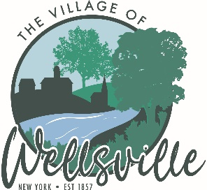

Village of Wellsville

Office of the Clerk
23 North Main Street * Wellsville, New York 14895
Phone: (585) 596-1754 * FAX: (585) 593-7260
711(TDD)

VILLAGE BOARD MEETING AGENDA
07-27-2026
Pledge to the Flag

Accept the minutes of the Unsafe Structure Hearing held on Monday, July 13, 2026.

Accept the minutes for the Regular Meeting held on Monday, July 13, 2026.

VISITORS: PLEASE TAKE NOTE Visitors on the agenda are limited to 10 minutes time
Visitors not on the agenda are limited to 3 minutes time

MAYOR’S BUSINESS:
- Discuss Code Guidelines and what requires a building permit in New York State.

TRUSTEES’ BUSINESS:

PEARSON:

- Request acceptance and approval of the vouchers listed in the Abstract of Vouchers dated July 27, 2026.
- Request acceptance and approval of the Treasurer’s financial reports, posting journal and bank reconciliations for June 2026.
COLLIGAN:

- Disposal of theater seating
- Babcock Theater Lease
- Status of Railroad Ave. Demolition
ROESKE:
- Nothing to discuss.
DIDION:
- Nothing to discuss.
POLICE DEPT:
- Request acceptance and Approval to auction two impounded vehicles.

FIRE DEPT:
- Nothing to discuss.

TOWN LIAISON:
- Nothing to discuss.
DPW:
- Request acceptance and Approval to sell surplus equipment.
CODE ENFORCEMENT:
- Nothing to discuss.
TREASURER:
- Request for Executive Session to discuss personnel matter.

Per NYS Amendment to the State’s Open Meeting Law, public records already available under FOIL, in addition to any resolution, law, rule, regulation, policy or any amendment, that is scheduled to be the topic of discussion at an open meeting, are available upon request to the extent practicable as determined by the Village of Wellsville. The Village of Wellsville will post board meeting agenda and minutes on its web site at www.wellsvillevillageny.gov

