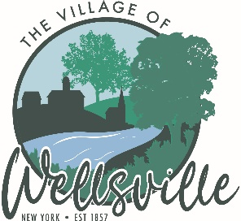

Village of Wellsville

Office of the Clerk
23 North Main Street * Wellsville, New York 14895
Phone: (585) 596-1754 * FAX: (585) 593-7260
711(TDD)

VILLAGE BOARD MEETING AGENDA
2-9-2026

Pledge to the Flag

5:45 pm Public Hearing: Resolution 25/26-13 Granting a Cable Television Franchise held by Spectrum Northeast LLC in the Village of Wellsville

Accept the minutes for the Regular Meeting held on Monday, January 26, 2026.

VISITORS: Barry Glickstein – requests to discuss sale of theater items.

MAYOR’S BUSINESS:

- Request acceptance and approval Resolution 25/26-13 Granting a Cable Television Franchise held by Spectrum Northeast LLC in the Village of Wellsville.
- Discuss NYMPA memo to Member Systems and NYMPA electricity rates.
- Notify public of the Informational Meeting that will be held on February 12th, 2026 at 5:30pm in the Village Board Room for the 2nd Round of NY Forward Small Project funding.
- Donations for the Babcock Theater Preservation Society from the Parking Meters over the Holiday periods from Thanksgiving to New Years was $813.86.
- Request acceptance and approval to use IEEP funds to purchase crossing lights for Main Street.

TRUSTEES’ BUSINESS:

PEARSON:

- Request acceptance and approval of the vouchers as listed in the Abstracts of Vouchers dated February 9, 2026.
- Request acceptance and approval of the January 2026 Bank Reconciliations, Financial Reports and Posting Journal

ROESKE:

- Nothing to discuss

COLLIGAN:

- Nothing to discuss

POLICE DEPT

- Acceptance and Approval of the Special Event Permit to hold the Shortest St. Patrick’s Day Parade to be held on March 13th, 2026 at 4-7pm.

FIRE DEPT:

- Nothing to discuss

TOWN LIAISON:

- Nothing to discuss

DPW:

- Request acceptance and approval.

TREASURER:

- Notification to the Board of Trustees and the Mayor of the 26-27 Financial Planning Calendar.

