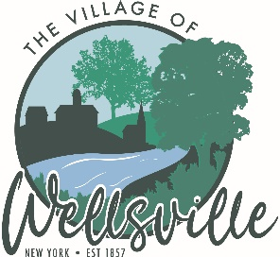

Village of Wellsville

Office of the Clerk
23 North Main Street * Wellsville, New York 14895
Phone: (585) 596-1754 * FAX: (585) 593-7260
711(TDD)

VILLAGE BOARD MEETING AGENDA
1-12-2026

Pledge to the Flag

Accept the minutes for the Regular Meeting held on Monday, December 22, 2025.

VISITORS:

MAYOR’S BUSINESS:

- Request acceptance and approval of Resolution No. 25/26-12, amendment to Local Law #6 of 2025, Establishment of Temporary No Parking/Tow Away Zones Amendment to Local Law #6 of 2025.

- Request and approval of the Application for a Special Event Permit for the Battling Mind Striders Walk. The event will be Saturday, May 2, 2026 starting at 10:00 am. Map of the walk provided.

TRUSTEES’ BUSINESS:

PEARSON:

- Request acceptance and approval of the vouchers as listed in the Abstracts of Vouchers dated January 5th, 2026 and January 12th, 2026.

MONROE:

- Request acceptance and approval of two Applications for a Special Event Permit for the Dyke Street Engine Co. # 2 for Chicken BBQs to be held at 89 E. Hanover Street, Wellsville on Saturday, March 22nd, 2026 and Saturday, October 25th, 2026 from 12:00 pm to 2:00 pm.

ROESKE:

- Nothing to discuss
COLLIGAN:

- Nothing to discuss

POLICE DEPT

- Request acceptance and approval of the sale of a impounded vehicle for scrap.

FIRE DEPT:

- Nothing to discuss

TOWN LIAISON:

- Nothing to discuss

DPW:

- Nothing to discuss

TREASURER:

- Request executive session to discuss the employment history of a particular person.

- Request a public hearing be scheduled for the review and approval of the Charter Communications Franchise Agreement for Cable Television System.

