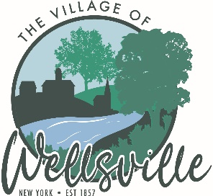
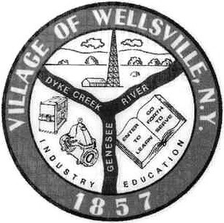
Village of Wellsville

Office of the Clerk
23 North Main Street * Wellsville, New York 14895
Phone: (585) 596-1754 * FAX: (585) 593-7260
711(TDD)

VILLAGE BOARD MEETING AGENDA
3-9-2026

Pledge to the Flag

Accept the minutes for the Regular Meeting held on Monday, February 23, 2026.

VISITORS:

MAYOR’S BUSINESS:

- Discuss the creation of Wellsville creating a “James Raptis” Day.
- Discuss Allegany County Landbank giving the Village of Wellsville property located at 172-180 E. State Street.
- Request executive session to discuss the employment history of a particular person.
- Request acceptance and approval for the Wellsville Area Chamber of Commerce Main Street Festival on Saturday July 18. 2026 from 9 am to 4 pm.
- Request acceptance and approval for the Wellsville Area Chamber of Commerce Wine Walk on Saturday May 2, 2026 from 1 pm to 4 pm.
- Request acceptance and approval of the NYMPA Resolution.

TRUSTEES’ BUSINESS:

Pearson:

- Request acceptance and approval of the vouchers as listed in the Abstracts of Vouchers dated February 26, 2026 and March 9, 2026.

Roeske:
- Request acceptance and approval of the Wellsville Secondary School Graduation to be held Friday, June 26, 226 at 7:00 pm.

Colligan:

- Discuss Allegany County IDA EPA Brownfields grant program that has information and funding in regards to environmental testing for the Theater.

Didion:

- Nothing to discuss

POLICE DEPT

- Nothing to discuss.
FIRE DEPT:

- Nothing to discuss

TOWN LIAISON:

- Nothing to discuss

DPW:

- Request acceptance and approval to make Hunter Kear (Line Helper) permanent as he has completed his 120-day probation period.
- Request approval to accept the bid for the Village Refuse Contract.

TREASURER:

- Treasurer presents the “Tentative 2026-2027 Village Budget”
- Request acceptance and approval for the purchase of a TV for the Board Room.
- Discuss the Code Enforcement Report.
- Discussion in regards to Police Car repairs.

