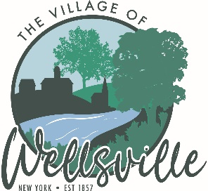

Village of Wellsville

Office of the Clerk
23 North Main Street * Wellsville, New York 14895
Phone: (585) 596-1754 * FAX: (585) 593-7260
711(TDD)

VILLAGE BOARD MEETING AGENDA
2-23-2026

Pledge to the Flag

Accept the minutes for the Public Hearing held on Monday, February 9, 2026
Accept the minutes for the Regular Meeting held on Monday, February 9, 2026.

VISITORS:

MAYOR’S BUSINESS:

- Request acceptance and approval of appointing Ken Didion as Trustee for the Village of Wellsville.
- Request from the Chamber for permanent markings on the curbing for Balloon Rally Main Street Festival.
TRUSTEES’ BUSINESS:

Pearson:

- Request acceptance and approval of the vouchers as listed in the Abstracts of Vouchers dated February 23, 2026.

Roeske:

- Nothing to discuss

Colligan:

- Request the acceptance of the retirement of Brent W. Roberts effective 7/24/26.
- Request acceptance and approval to hire Water Treatment Plant Trainee.
Didion:

- Riverwalk Bird Enhancement Project – Birgie Miller

POLICE DEPT

- Nothing to discuss.
FIRE DEPT:

- Nothing to discuss

TOWN LIAISON:

- Nothing to discuss

DPW:

- Request acceptance and approval to make Zachary Roberts (WWTP Operator Trainee) permanent as he has completed his 120-day probation period.
- Request acceptance and approval to award bids for Supply & Delivery of Wastewater Treatment Chemicals and Supply & Delivery of Water Treatment Chemicals for Potable Water.

TREASURER:

- Nothing to discuss.

