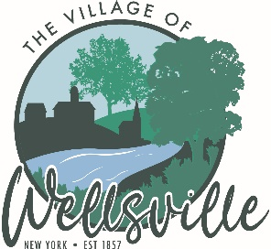

Village of Wellsville

Office of the Clerk
23 North Main Street * Wellsville, New York 14895
Phone: (585) 596-1754 * FAX: (585) 593-7260
711(TDD)

VILLAGE BOARD MEETING AGENDA
03-23-26

Pledge to the Flag

Accept the minutes for the Regular Meeting held Monday, March 9, 2026.

VISITORS: Barry Glickstein (updates on the marquee)

Liz Volk (splash pad)

CORRESPONDENCE: DAR letter

MAYOR’S BUSINESS:

- Official James Raptis Day Proclamation
- Executive Session to discuss pending litigation
- Discuss 60 N. Brooklyn Ave.

TRUSTEES’ BUSINESS:

Pearson:

- Request acceptance and approval of the vouchers as listed in the Abstracts of Vouchers dated March 9, 2026, and March 23, 2026.

- Request acceptance and approval of the Treasurer’s financial reports, posting journal and bank reconciliations for February 2026.

Roeske:

- Nothing to discuss

Colligan:

- Nothing to discuss

Didion:

- Nothing to discuss

POLICE DEPT

- Nothing to discuss.
FIRE DEPT:

- Nothing to discuss

TOWN LIAISON:

- Nothing to discuss

DPW:

- Notification to the Board that an emergency purchase was made to repair the JCB Handler for the Sewer Department. The cost of this repair is estimated to be a little less than $22K. This is a necessary piece of equipment used to move sludge.

TREASURER:

- Executive to discuss employment history of a particular person.
- The Public Hearing for the 2026-2027 Village Budget will be held April 13, 2026 at 5:30pm.
- Request acceptance and approval of a revised contract with Barth Consulting for the second round of projects in the NY Forward Small Project Fund.

