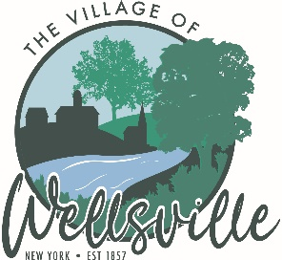

Village of Wellsville

Office of the Clerk
23 North Main Street * Wellsville, New York 14895
Phone: (585) 596-1754 * FAX: (585) 593-7260
711(TDD)

VILLAGE BOARD MEETING AGENDA
08-10-2026
Pledge to the Flag

Accept the minutes for the Regular Meeting held on Monday, July 27, 2026.

VISITORS: PLEASE TAKE NOTE Visitors on the agenda are limited to 10 minutes time
Visitors not on the agenda are limited to 3 minutes time
MAYOR’S BUSINESS:
- Village of Wellsville Water/WWTP award of, not to exceed, $50,000 for the NYS Strengthening Essential Cybersecurity for Utilities and Resiliency.
- Discuss User Agreement for the Babcock Theater Preservation Society.
- Discuss The Regulation of Yard Signs on Public Land.

TRUSTEES’ BUSINESS:

PEARSON:

- Request acceptance and approval of the vouchers listed in the Abstract of Vouchers dated August 10, 2026.
COLLIGAN:

- MACE activities report for July 2026.
ROESKE:
- Nothing to discuss.
DIDION:
- Nothing to discuss.
POLICE DEPT:
- Nothing to discuss.

FIRE DEPT:
- Nothing to discuss.

TOWN LIAISON:
- Nothing to discuss.

DPW:
- Acceptance and Approval to hire Dylan Dunbar as Water-Wastewater Maintenance Worker.
CODE ENFORCEMENT:
- Nothing to discuss.
TREASURER:
- Discuss the SRO Agreement with the Wellsville CSD.

Per NYS Amendment to the State’s Open Meeting Law, public records already available under FOIL, in addition to any resolution, law, rule, regulation, policy or any amendment, that is scheduled to be the topic of discussion at an open meeting, are available upon request to the extent practicable as determined by the Village of Wellsville. The Village of Wellsville will post board meeting agenda and minutes on its web site at www.wellsvillevillageny.gov

