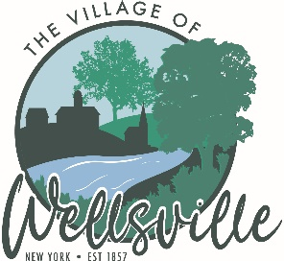

Village of Wellsville

Office of the Clerk
23 North Main Street * Wellsville, New York 14895
Phone: (585) 596-1754 * FAX: (585) 593-7260
711(TDD)

VILLAGE BOARD MEETING AGENDA
1-26-2026

Pledge to the Flag

Accept the minutes for the Regular Meeting held on Monday, January 12, 2026.

VISITORS:

MAYOR’S BUSINESS:

- Request acceptance and approval of LaBella as the Environmental Professional for the NY Forward Small Project Fund.
- Request executive session regarding a legal obligation.

TRUSTEES’ BUSINESS:

PEARSON:

- Request acceptance and approval of the vouchers as listed in the Abstracts of Vouchers dated January 26th, 2026.

ROESKE:

- Nothing to discuss

COLLIGAN:

- Discuss re-allocation of NY Forward grant funding for the “Well” Project.
- Request acceptance and approval to add Arthur J. Kellogg Jr. (WFD Tag# 090) to the rolls at The Dyke Street Engine Company #2, Inc. Chief Day has approved and signed the application.
- Request acceptance and approval to add Cassandra R. Kellogg (WFD Tag# 091) to the rolls at The Dyke Street Engine Company #2, Inc. Chief Day has approved and signed the application.

POLICE DEPT

- Nothing to discuss

FIRE DEPT:

- Nothing to discuss

TOWN LIAISON:

- Nothing to discuss

DPW:

- Request acceptance and approval to issue Request for Qualifications (RFQ) to select a Water Infrastructure Project Engineering Firm.

TREASURER:

- Request executive session to discuss the employment history of a particular person.

