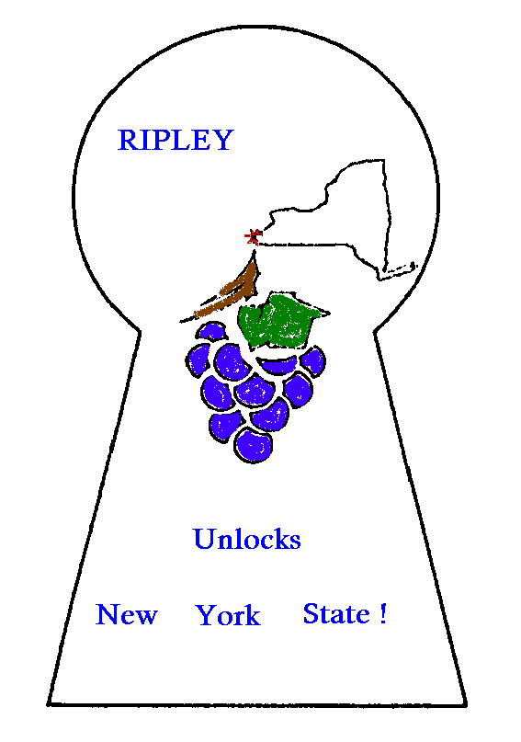

**Town of Ripley**

Text Messaging Service Agreement

By signing this agreement, you are authorizing the Town of Ripley to send you text messages. You may cancel at any time, by texting the word “STOP”.

Please check the following items in which you’d like to receive text messaging:

___ Communications from the Clerk’s office

___ Communications from the Water and Sewer department

Print Name: _________________________________________

Signature: ___________________________________________

Date: _______________________________________________

Phone Number: _______________________________________