Planning Board Minutes
September 21, 2026
6:00 p.m.

PRESENT: Joe Flikkema – Chairman
Linda Anderson
Julie Jackson-Forsberg
Diane VanDewark
Robert Whitman
Absent: Dan Johnson

Others present were Attorney Joel Seachrist, Robert VonVolen, Otto Knoll, and Paul Hazzard.

Chairman Joe Flikkema opened the meeting at 6:30 p.m. and noted the agenda for tonight’s meeting included two Special Use Permits for Stand Alone Accessory Buildings.

Chairman Flikkema noted the first application was from Robert VonVolen, 1314 S. Main Street, Jamestown (Kiantone), New York, for a Special Use Permit to build a 50’x 100’ Stand-Alone Accessory building at property located on S. Main Street. Said property is owned by him and known as Section 421.00, Block 2, and Lot 1.1 of the official tax map of the Town of Busti. Property is located in the Conservation/Agricultural (CA) District. Mr. VonVolen’s application was tabled at the August 17, 2026 Planning Board meeting due to questions from the board that could not be answered because of Mr. VonVolen not being present. present. The board discussed the size of the building exceeding the maximum amount of 4,000 square feet permitted in the code for the Special Use Permit. There was also discussion regarding the use of the building.
Mr. Flikkema read the following section from Town of Busti Zoning Code:

§ 405-701Stand-alone accessory buildings.
No accessory building ordinarily may be erected on a vacant lot. However, accessory buildings as stand-alone structures may be permitted, upon issuance of a special use permit and only in the Residential/Agricultural (RA), Conservation Agricultural (CA), and Conservation/Agricultural/Mobile Home Park (CAMP) Districts, subject to the following requirements:
A.
The use of a stand-alone accessory building must be located on a lot of at least four acres.
B.
Notwithstanding any other provisions of the Town of Busti Zoning Law, front, side, and rear yard setbacks of the stand-alone accessory building shall be determined by the Town Board (Planning Board) based upon site specific considerations and as part of the issuance of a special use permit.
C.
The stand-alone accessory building shall be of a size and design commensurate with the lot on which it is placed and with the surrounding neighborhood. In no case shall a stand-alone accessory building exceed 4,000 square feet in size. There shall be no more than one stand-alone accessory building per lot.
D.
The structure must be demonstrated to have a tangible nexus and purpose related to the land itself. The stand-alone accessory building may not be used for commercial purposes. Typical allowable uses are as storage for personal tools and recreational vehicles used on the property, a gardening shed, a sugar house or similar low-impact, rural use.
E.
No outdoor storage of any type shall occur on the lot.
F.
The use shall not interfere or conflict with the peaceful enjoyment of neighboring residential uses.
G.
In exercising its approval powers, the Town Board (Planning Board) may, upon proper finding, impose such reasonable conditions relating to screening, buffering and other mitigative measures incidental to the application for a special use permit.
H.
Such other materials as the Town Board (Planning Board) deems necessary upon which to determine the impact of such specially permitted use must be submitted.

The Board questioned the proposed size of the building and its relationship to the property. The applicant stated that the building was intended for personal use and storage of vehicles, boats and other personal property, and that he was a hobbyist interested in hobby farming. The Board expressed concerns regarding the number of vehicles and other items currently located on the property and whether the proposed building had a tangible nexus to the property itself.
The applicant explained that he was not proposing commercial use and wanted to protect and store his personal property. The Board discussed the requirement that the use be particular to the property and related to the owner's actual use of the property. It was explained that if the proposed building could be moved to another property and accomplish the same purpose of storing vehicles and boats, the Board had difficulty determining a particular nexus to this parcel.
The Board discussed the maximum permitted size of the standalone accessory building and advised the applicant that the proposed building would need to be reduced to 4,000 square feet unless an area variance was obtained from the Zoning Board of Appeals. The Board noted that the applicant had sufficient acreage and appeared to have adequate setbacks and space for a building, but the proposed size of 50’x100’ exceeded the maximum square footage requirement was established in the zoning code.
The possibility of placing a dwelling on the property was discussed. The Board explained that if the property contained a legitimate dwelling, a building could potentially be considered an accessory structure to the dwelling rather than a standalone accessory building. Mr. VonVolen stated that he would be willing to consider constructing a dwelling on the property.
The Board advised the applicant to speak with Code Enforcement Officer, Jeff Swanson, regarding a proposed dwelling structure and the proposed accessory structure to ensure that it meets the building code and zoning requirements. The Board explained that the structure would need to be a legitimate dwelling with the required bedrooms, kitchen and bathrooms and would need to comply with applicable requirements.
Mr. VonVolen asked about requirements for a well and septic system. The Board explained that applications for a well and septic system would be made through the County and County Health Department, rather than the Town, although proof of those approvals will eventually be required for the building process.
The Board discussed whether the applicant should voluntarily withdraw the current application rather than have the Board vote on it. It was explained that a voluntary withdrawal would have no adverse effect and would be treated as though the application had not been acted upon. Mr. VonVolen expressed concern about receiving a negative vote and indicated that he would consider pursuing the alternative of establishing a dwelling on the property.
A straw poll was discussed rather than taking an official vote. Board members indicated that they would be willing to consider the proposal if the applicant obtained the necessary variance. The applicant was advised that pursuing the dwelling option and working with Jeff Swanson would provide another path rather than receiving a denial of the current application.
Mr. VonVolen thanked the Board, stated he would contact Code Enforcement Officer, Jeff Swanson, regarding constructing a dwelling structure on the property and left the meeting.
Chairman Flikkema noted the next application was the application of Otto Knoll, PO Box 233, Celoron, New York, for a Special Use Permit to build a 36’x 40’ Stand-Alone Accessory building at property located on Cowing Road. Said property is owned by him and known as Section 418.00, Block 3, and Lot 8 of the official tax map of the Town of Busti. Property is located in the Residential/Agricultural (RA) District.

The Board reviewed the application and noted that the proposed building was under the 4,000-square-foot requirement. Mr. Knoll explained that he had owned the property for 44 years and plans to purchase a small tractor and implements; the building would be used to store the tractor and a boat and have additional room to work on and groom the property. The applicant stated that the building would be for personal storage and that he intended to improve the property.
The proposed conditions of the Special Use Permit were reviewed. The applicant shall undertake the use in accordance with the application and plans submitted to the Town, the conditions of the Special Use Permit, and the Town of Busti zoning requirements.
The pole barn shall be used solely for personal storage. No commercial use of the property or structures authorized by the permit shall occur. The structure shall be constructed substantially in accordance with the site plan.
The board reviewed the following SEQR documents:
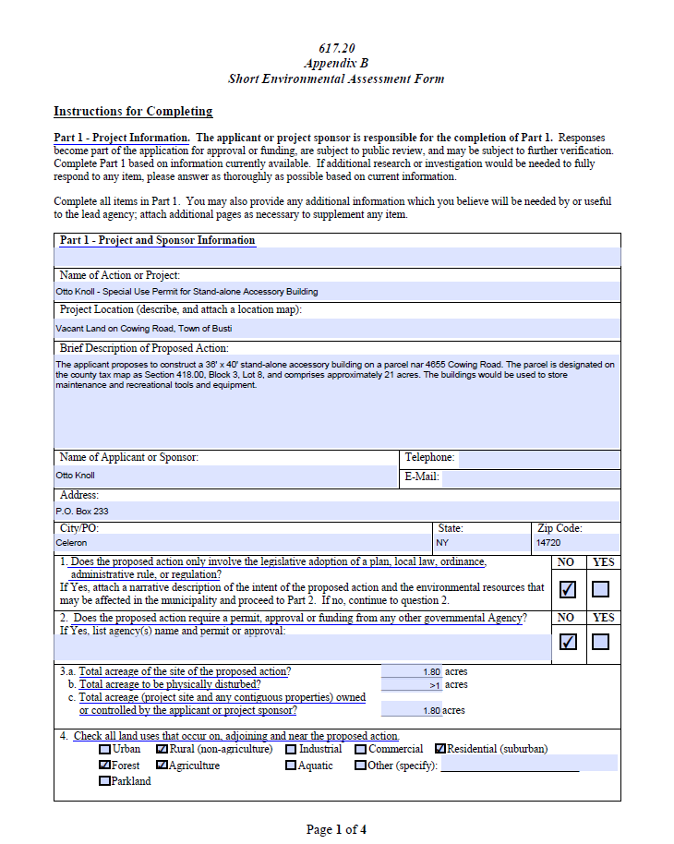
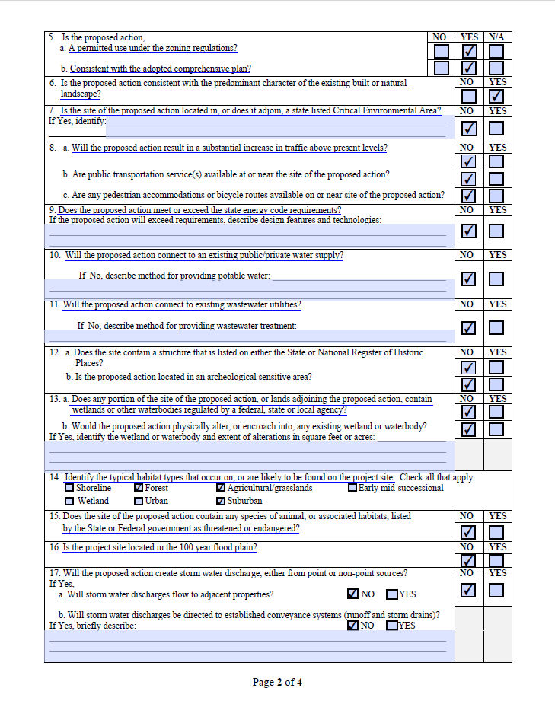
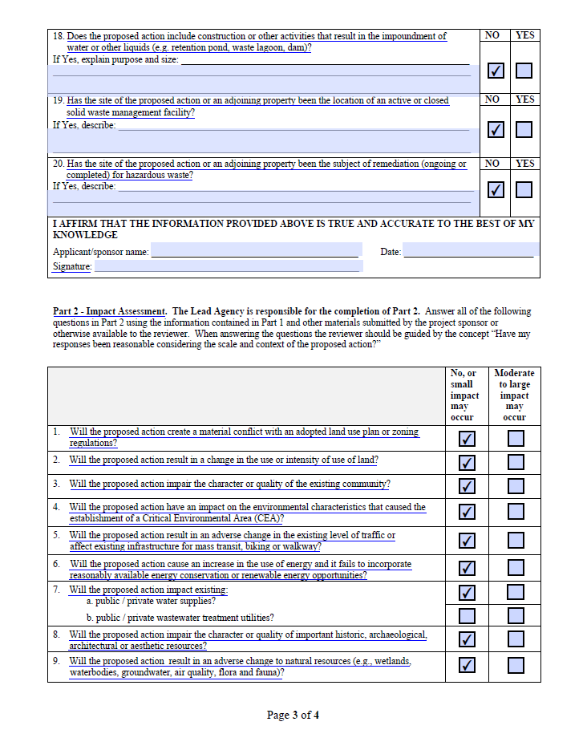
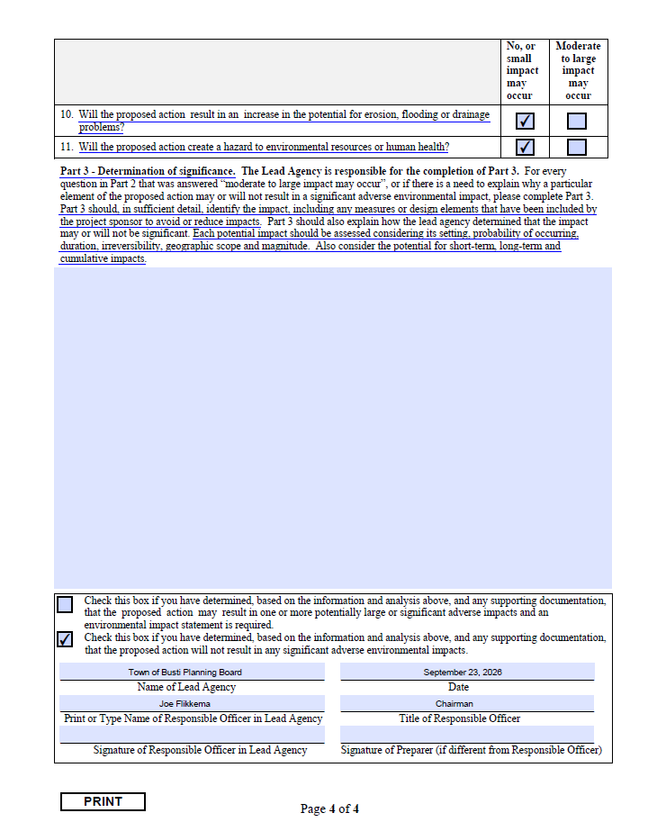
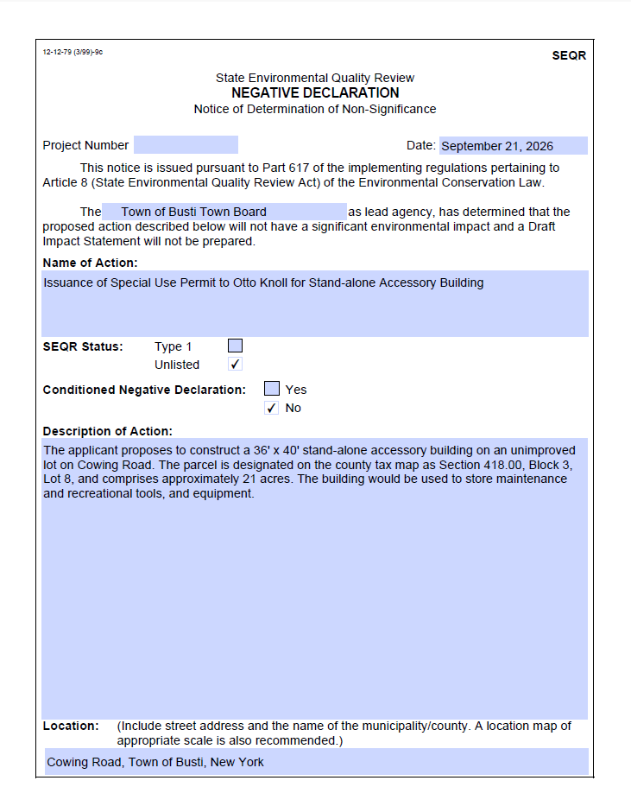
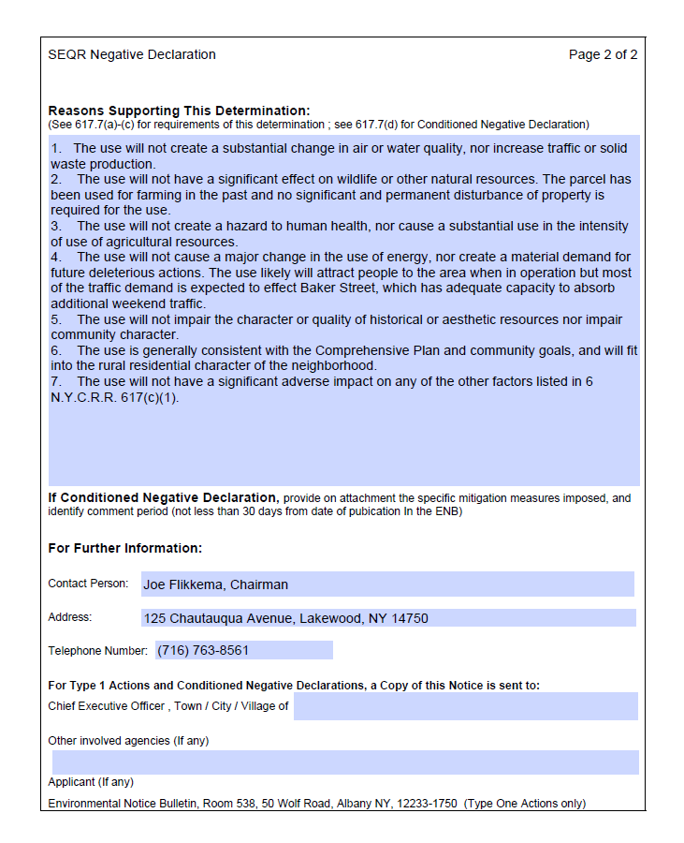
RESOLUTION

Moved by Robert Whitman, seconded by Julie Jackson-Forsberg:

WHEREAS, Otto Knoll (hereinafter, the “Applicant”) has submitted an application to construct a stand-alone accessory building on a parcel owned by him on Cowing Road, which is designated on the Chautauqua County tax map as Section 418.00, Block 4, Lot 8, and

WHEREAS, the proposed use has been subject to environmental review pursuant to Article 8 of the New York State Environmental Conservation Law (State Environmental Quality Review Act), including the preparation and review of a short Environmental Assessment Form, and

WHEREAS, Part 617 of the implementing regulations pertaining to the State Environmental Quality Review Act requires this Board to determine and give notice of the environmental impact of the proposed use, and

WHEREAS, the Board has determined that the proposed use will not have a significant environmental impact,

NOW, THEREFORE, BE IT RESOLVED, that the Planning Board hereby approves Parts I and II of the Environmental Assessment Form, issues the attached Notice of Determination of Non-Significance, also known as a Negative Declaration, for the proposed use, and authorizes the Supervisor to complete and sign the Environmental Assessment Form accordingly.

All in favor carried

TOWN OF BUSTI
SPECIAL USE PERMIT

Action of the Board:
To consider the application of Otto Knoll for a Special Use Permit to construct a 36' × 40' pole building on a parcel owned by him located just east of 4655 Cowing Road, which is designated on the Chautauqua County tax map as Section 418.00, Block 3, Lot 8, containing approximately 21 acres.

Resolution moved by: Robert Whitman

Seconded by: Joe Flikkema

WHEREAS, Otto Knoll (hereinafter, the “Applicant”) has requested a Special Use Permit authorizing him to construct a 36' × 40' pole building on a parcel owned by him located just east of 4655 Cowing Road, which is designated on the Chautauqua County tax map as Section 418.00, Block 3, Lot 8, said parcel containing approximately 21 acres, and

WHEREAS, the issue of compliance with the State Environmental Quality Review Act has been addressed, and a Negative Declaration has been issued after examination of the record and a public hearing, and

WHEREAS, the Town Board has considered all the facts and papers before it, including the application received by the Town Clerk on August 4, 2026, and has heard those wishing to be heard at a public hearing held September 21, 2026, and finds justification to approve the application subject to the qualifications hereinafter set out,

NOW, THEREFORE, BE IT RESOLVED, that the application for a Special Use Permit to construct a 36' × 40' pole building and to use the property for family picnicking, camping, and hunting (the “Use”), be and hereby is authorized and approved subject to the conditions and requirements hereinafter set out:

1. The Applicant shall undertake the Use in accordance with the application submitted to the Town, including the site plan depicting the driveway and culvert on Cowing Road, gravel parking and access areas, gravel building base, and the location of the 36' × 40' pole building, except as hereinafter modified, and agrees to be bound by the terms of the application, the conditions of this permit, and the Town of Busti Zoning Code, which are as follows:

a. The 36' × 40' pole building permitted herein shall be used as an accessory structure in connection with family picnicking, camping, and hunting on the property, and shall not be used as a residence nor for any commercial use.

2. The terms, conditions, and requirements of this permit bind and obligate the Applicant, his successors, and assigns. This permit shall not be assigned or transferred, in whole or in part, without the prior written consent of the Town, except as otherwise herein noted.

3. Any failure or omission on the part of the Applicant to carry out any condition or requirement herein or in accordance with the terms or requirements of any statute, local law, ordinance or regulation, may be deemed a violation of the Town of Busti Zoning Law and unless corrected in not more than 10 days following the service of written notice of such violation upon the Applicant, may subject them to the penalties therein. Continued violations after written notice may result in revocation of this Special Use Permit.

4. This Special Use Permit shall become effective after the Applicant approves each and every provision hereof and agrees to be bound by all of the terms herein contained in consideration of the granting of this Special Use Permit.

Dated: September 21, 2026

Vote: Aye Nay

Joe Flikkema X _____

Robert Whitman X _____

Julie Jackson-Forsberg X _____

Diane VanDewark X _____

Linda Anderson X _____

Daniel Johnson - Absent

* * * * * *

The Applicant, Otto Knoll, agrees to abide by all the terms of this Special Use Permit.

Dated: September ___, 2026

_______________________________________
Otto Knoll

The applicant was advised to meet with Jeff Swanson regarding signing the Special Use Permit and obtaining the required building permit.
Robert Whitman moved to adjourn the meeting at 7:05 p.m., which was duly moved by Diane VanDewark.
All in favor, carried.
Respectfully given,

_____________________
Darlene H. Nygren
Town Clerk

